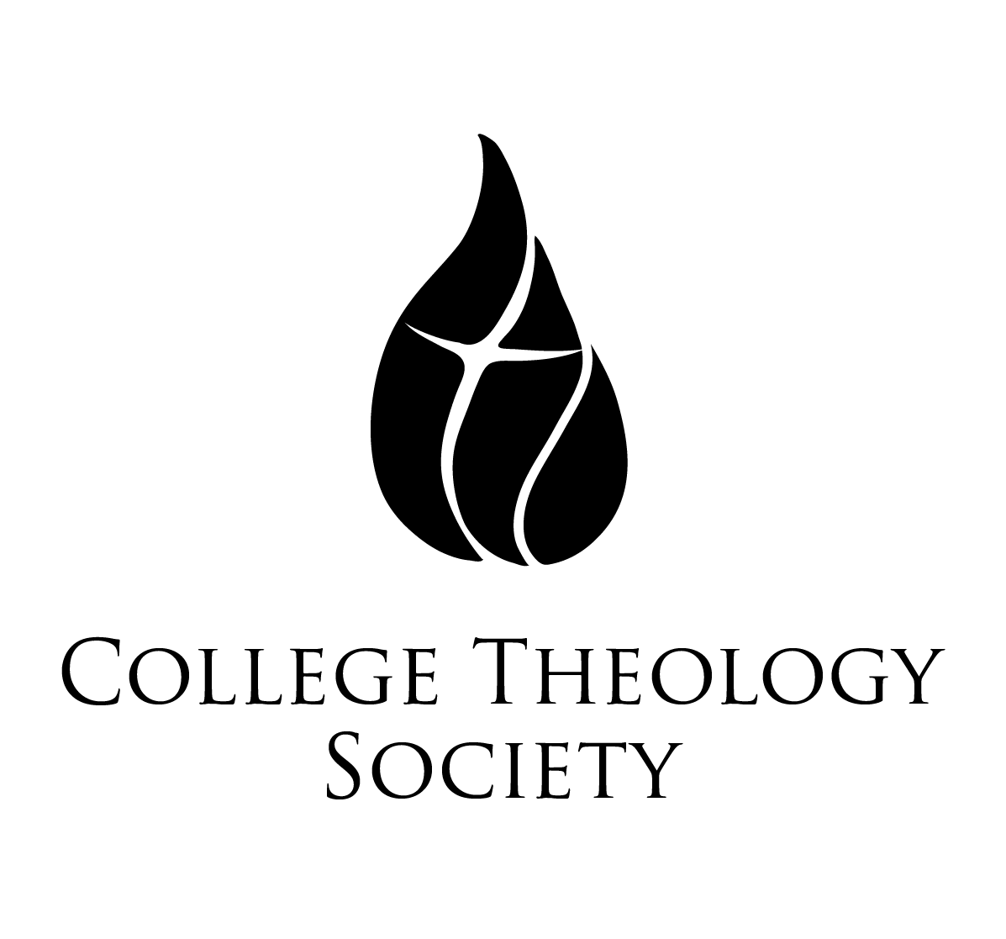 | Father David Gentry-Akin, M.Div., STL, STD  Executive Director of National Conventions  College Theology Society  Saint Mary’s College of California  1928 Saint Mary’s Road, PMB 3058  Moraga, CA 94575-2715  collegetheology.org  dgentry@stmarys-ca.edu  925.631.4790
Sixty-Fourth Annual Convention
Saint Catherine University, Saint Paul, Minnesota
Thursday, May 31-Sunday, June 3, 2018
Book Exhibitor Form

Please return this form via email or hard copy to the above address no later than May 1, 2018.

Name:

Publishing House:

E-Mail Address:

Telephone:

How Many Tables Will You Need?

Anything Else That It Would Be Helpful For Us to Know:

At the close of the convention, please

Return any unsold books to us, using the prepaid, self-addressed mailing labels that our representatives will provide before they leave Saint Paul.

Donate any unsold books to the Saint Catherine University library, with an acknowledgment of your gift to be sent to the address below

